Good afternoon,

Thank you again for participating in the RW Turner Lab’s Athlete Brain Health and Aging Study. In hopes of keeping an open line of communication, we’re excited to share our first newsletter with information and updates on our study, as well as a preliminary summary of findings from our focus groups.

Study Information and Updates

The Athlete Brain Health and Aging Study currently has 196 athletes enrolled in our study from all around the United States. Of those athletes:
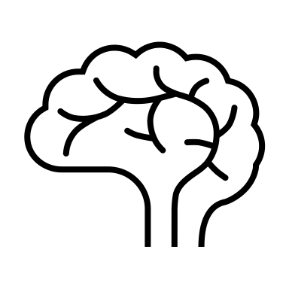
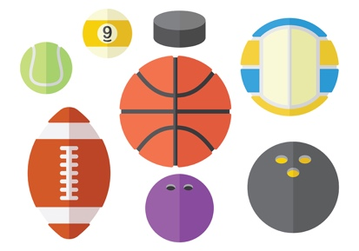
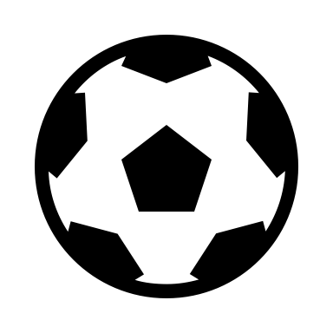
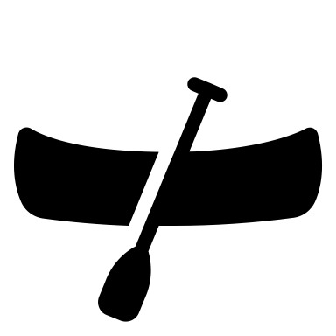
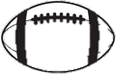
- 104 former professional football players,
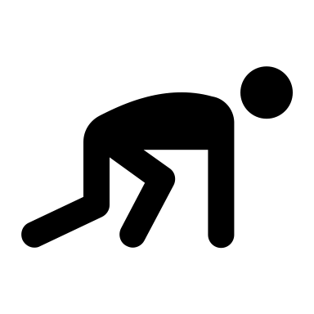
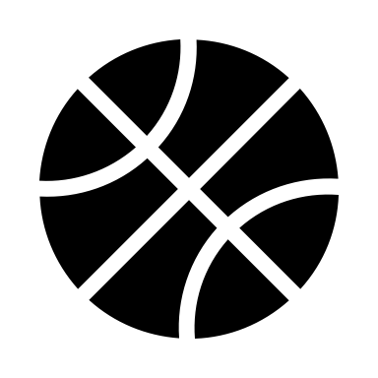
- 26 former college D-1 football players, and
- 18 former non-contact D-1 athletes

have completed our virtual health surveys. Our virtual health surveys are still ongoing, and we are eager to announce that we will soon begin virtual cognitive assessments, as well as in-person testing at Duke University.

In-person testing will include:
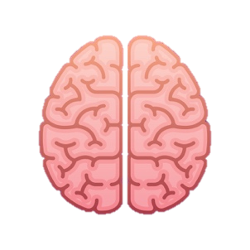
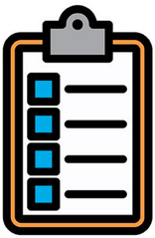
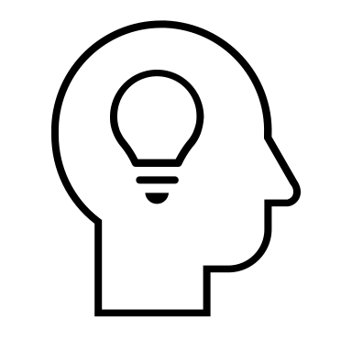
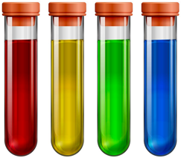
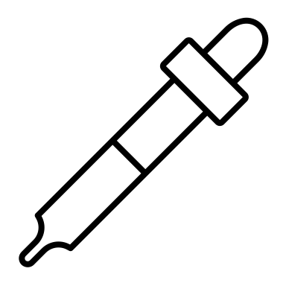
MRI scan

Cognitive assessment/questionnaire
Blood/urine sample collection

Further information on our virtual cognitive assessments and in-person tests will be sent in separate emails to all of our participants. If you are currently in North Carolina or the East Coast, and are interested in travelling to Duke University for our in-person tests, we encourage you to email at rwturnerlab@gwu.edu.

Our team has also been analyzing the qualitative data from our focus groups that were completed by a subset of our participants this past summer. We sincerely thank all of our focus group participants for sharing valuable insights and experiences on their lives as former athletes. A short, preliminary summary of our findings from our focus groups is written below.

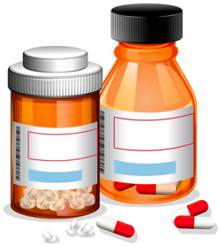
Focus Group Summary

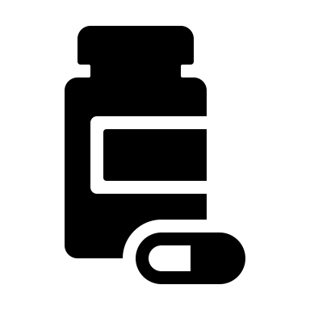
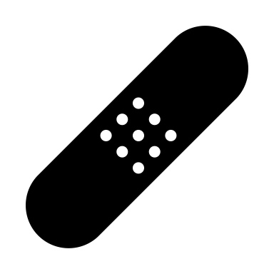
No matter the sport, injuries were expected and experienced during the athletic career of our focus group participants. Former football players recalled experiencing minor injuries on a regular basis. However, most athletes chose short-term treatment, if any, so they could keep playing. Taking pain medication was a common short-term solution. Some players found themselves unable to participate in games or even carryout day-to-day activities without medication. A larger theme among players focused on chronic pain and damage from their careers that were often not given the proper amount of time to rest and heal. Often, these injuries seemed to become moderately to severely debilitating in retirement.

“For some, experiencing injury and disability became the new normal”

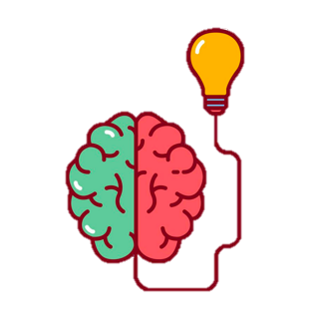
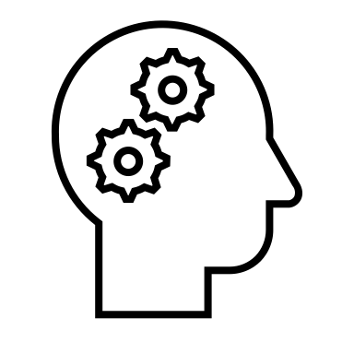
Former football players at both the college and professional level revealed that they typically only received treatment for serious head injuries including concussions that led to loss of consciousness. As expected, non-contact athletes did not have concerns about brain health and memory. In contrast, former football players were worried, especially as older players they knew experienced dementia. While they weren’t aware of it at first, there were signs that memory issues, possibly related to sports involvement, were beginning to emerge. Acknowledging the possible consequences of football, several participants questioned if they would allow their children to play.

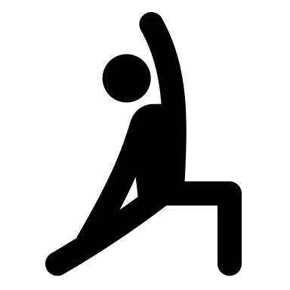
There is a shared worry by many of our participants about whether or not their active life is going to be further curtailed in the near future. Despite the majority of our participants still exercising, the range of exercises they can do is limited. Pain and a growing lack of mobility were common factors. Our participants expressed concern that the damage and pain left over from a career of playing eventually leads to more limitations than for former non-athletes in their age groups. Eating healthily became harder when participants were no longer exercising at the same level to warrant the same diets they had as an athlete. After leaving their athletic career, most participants recalled fluctuating between working out frequently and taking a break but returned to exercising more because their bodies did not feel right.

“It was consistent that our participants reminded themselves that aging is normal and there is only so much they can control”

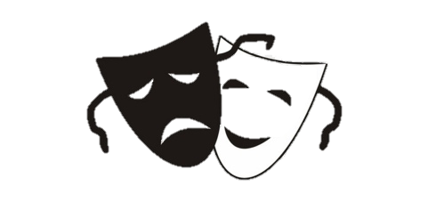
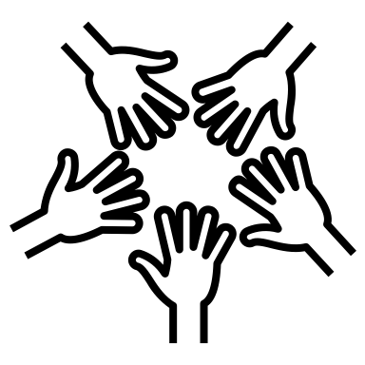
The focus groups provided valuable information about not only the physical effects of playing the participants’ respective sports, but also the psychosocial effects. Reported life-long benefits of sports participation included discipline, competitiveness, and teamwork skills. Still, athletes addressed how they were often overworked. Being emotionally or physically vulnerable was a sign of weakness. Former football players revealed that they would try to solve their problems alone because no one discussed how dangerous the sport was and they were expected to “suck it up”. Former athletes who reported seeing therapists and joining health and mental health groups for emotional support almost always joined after their athletic career.

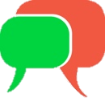
All groups found the transition process challenging. Some personally or knew of others who struggled financially, especially former NFL athletes who spent too fast. The participants overall felt unprepared for life after their sport, especially if their athletic careers were cut short due to injury. Following their careers, the athletes faced the task of creating a new identity. It is difficult to recreate the environment of a game and sports fans. While some players turned to additional activities, others turned to substance abuse to replace the structure that they lost as players. Participants pointed out that while playing a sport could cause trauma, it also often served as an outlet for anger and other emotions. Communicating with friends and family or mental health professionals was cited as the best resource to help with transitioning.

Last Notes

We would like to thank you again for your participation in our study. We hope to be in contact with you soon regarding next steps for The Athlete Brain Health and Aging Study and will continue to provide our participants with updates on our findings. Please feel free to reach out to us at rwturnerlab@gwu.edu if you have any questions about our study. We also encourage you to share any thoughts you might have on our focus group findings. We would love to hear back from you!

Sincerely,

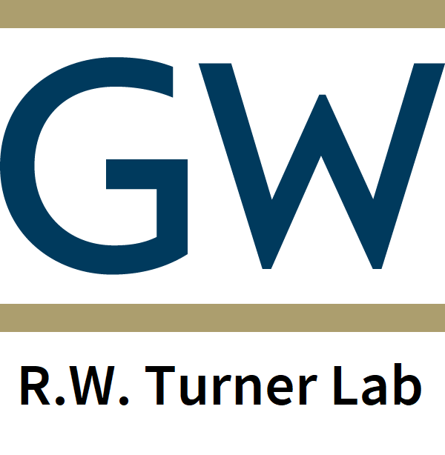
The RW Turner Lab
rwturnerlab@gwu.edu
@robertturnerphd
robertturnerphd
GWBrainHealthStudy
GW Brain Health Study
Stay Connected:

